How to use USB727 with MANDRIVA
Having used my Verizon PCMCIA card under Mandriva for 2 years now (the length of my contract) I was pleasantly surprised at how WASY it was to switch over to the USB727. The reason for the change from the card to USB was because when we bought my wife’s new laptop I was SHOCKED to find that it did NOT include a PCMCIA slot in the machine! Therefore I knew when our next opportunity to upgrade came I was going to HAVE to figure out a way to use the USB727, so that ALL the computers in the house could access the Inter net, at least make a valid attempt. So, I searched the net and found an article that had been written on using that device with PCLINUXOS.
Since PCLINUXOS is a subset of Mandriva, I figured they had to be similar is not the same!
So, let’s get started!
- First, make sure that the USB727 is NOT currently plugged into your pc, you don’t want any “discovery going on until your ready.
- A lot of Linux Distro’s and WM’s use different styles of the SU, SUDO or SU~ so whichever you’s uses, make sure your aware and comfortable with it.
- Open you Terminal (in my case its BASH, but there should be one in your tools/menu) it will open a black “dos like” box
- Once your at the command line, enter your version of SU <return> it will ask for your ROOT password, enter that and <return>
- First you’ll need to Uninstall whatever your “default usbserial driver is, so from the command line enter: # modprobe -r usbserial <return>
- Insert your USB727 and load the driver for the device.
  - Since I am using the USB727 my command looked like below.
  - If you are using a different device, see the Sprint Mobile Broadband document to find your vendor and product id. Simply select the Linux option from the dropdown box and you can then use the PDF.
  - BUT for the USB727 from your command line enter:
# modprobe usbserial vendor=0x1410 product=0x4100
<return>
- You probably wont see any feedback on the screen from that command, however once you get your command line back you’ll want to VERIFY that it was loaded.
- # dmesg|grep -i ttyUSB Should give you something similar to below:

[ 1863.832000] usb 2-1: generic converter now attached to ttyUSB0
[ 1863.836000] usb 2-1: generic converter now attached to ttyUSB1
[ 1863.836000] usb 2-1: generic converter now attached to ttyUSB2
[ 1863.840000] usb 2-1: generic converter now attached to ttyUSB3
- Now you are ready to setup the dialup connection. Navigate to the `Configure Your Computer` menu option as seen in the screenshot below.
  - 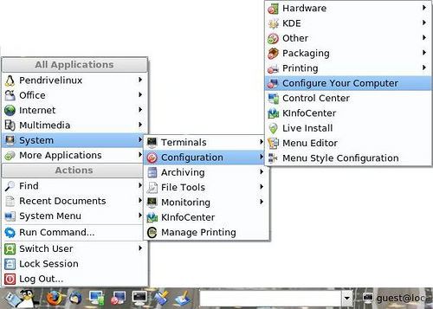
- This will give you the Control Center panel. We want to setup a new network interface:
  - 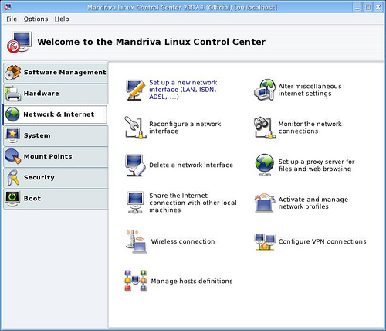
  - Select the Analog telephone modem (POTS) option.
  - 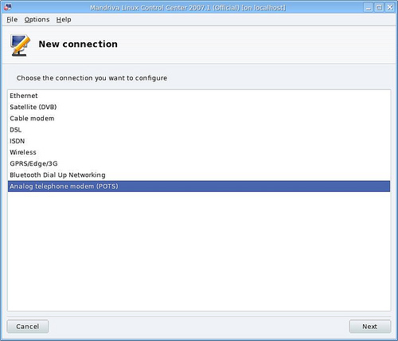
  - For the modem configuration, I only had the option for Manual choice. If you get any additional options, select appropriately.
  - 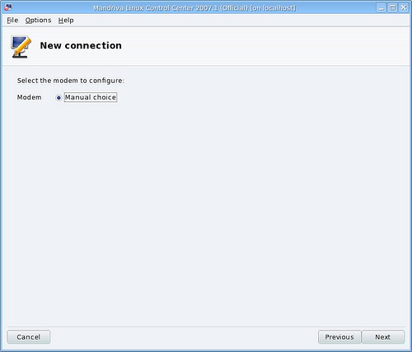
  - Select /dev/ttyUSB0
  - If you are using this, most likely you are in the United States. You will have to select the Unlisted option.
  - 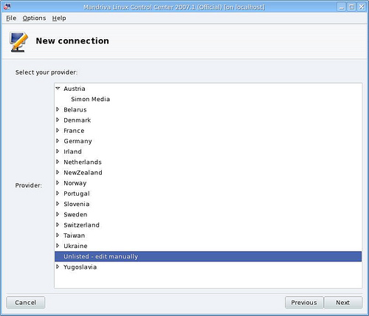
- Configure the login information. I was not able to find any password details so I simply used vzw for the password and it seemed to work fine.
  - 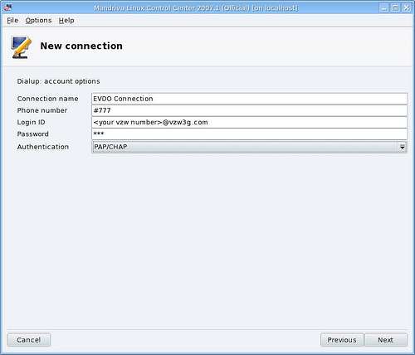
  - For the dialup IP parameters, you should select automatic.
  - 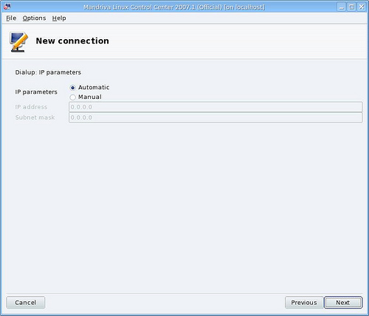
  - DNS settings should be set to automatic unless you have DNS servers that you would prefer to use. I’ve never found a need to premenantly set these.
  - 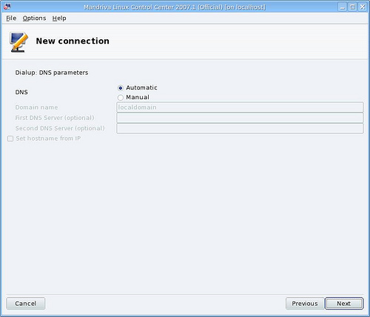
  - The gateway should be set to automatic.
  - 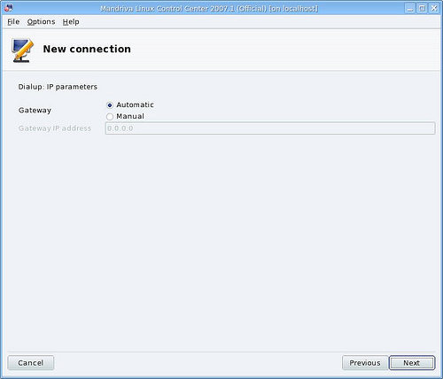
  - I like to allow users to manage the connection. The defaults are all unchecked.
  - 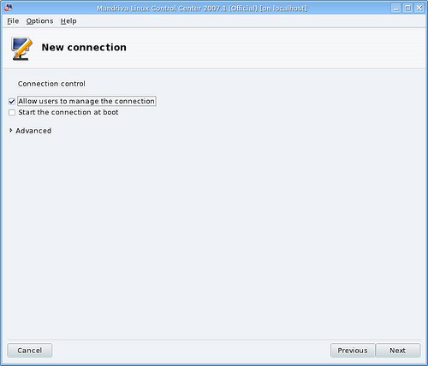
- Finally you can connect to the internet. It took some time to complete the connection, but ever since it has worked seemlessly.
  - More often than not, it WILL connect automatically.
  - HOWEVER I work in an area with a LOT of “wireless” connections, so sometimes I do need to go into the Network Control Center and manually turn those off and the EVDO on.
13) 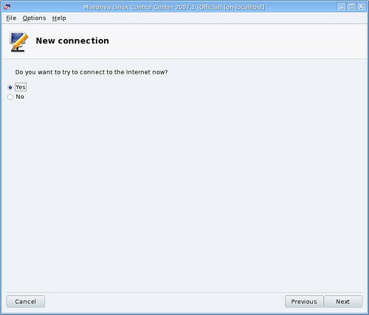
a. I used SpeedTest.net to test my speed and was getting 490kbps dowload and 209kbp upload.
b. Not as good as “wired broadband” but a whole lot more protable,.

If anyone can find where I found my info for Pendrivelinux, I’d love to give the originator some credit, drop me a line at jerome@thehess.org

